# Windows commands

## Ipconfig

**Syntax: ipconfig**

**Function:** cmd to show the NIC ip config and basic details.

**More details:** [Refer Microsoft Learn](https://learn.microsoft.com/en-us/windows-server/administration/windows-commands/ipconfig)

**Example:** 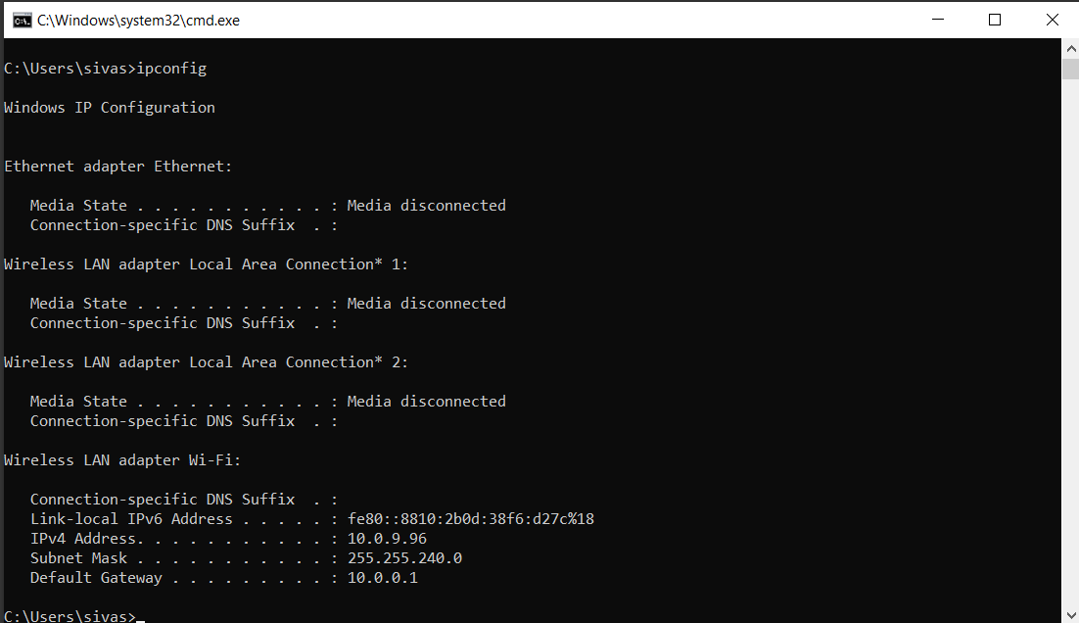

### ipconfig /all

**Syntax: ipconfig /all**

**Function:** cmd to show the all NIC details.

### ipconfig /flushdns

**Syntax: ipconfig /flushdns**

**Function:** cmd to clear the DNS cache.

## Ping

**Syntax: ping [ip address]**

**Function:** cmd to check weather the destination computer is reachable or not.

**More details:** [Refer Microsoft Learn](https://learn.microsoft.com/en-us/windows-server/administration/windows-commands/ping)

**Example:**

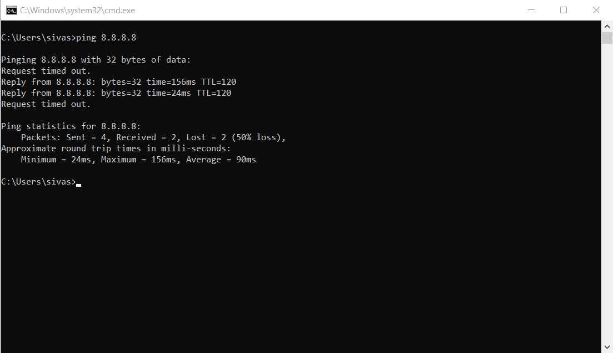

## Path ping

**Syntax: pathping [ip address]**

**Function:** cmd to check the packet loss and no of hops between source and destination.

**More details:** [Refer Microsoft Learn](https://learn.microsoft.com/en-us/windows-server/administration/windows-commands/pathping)

**Example:**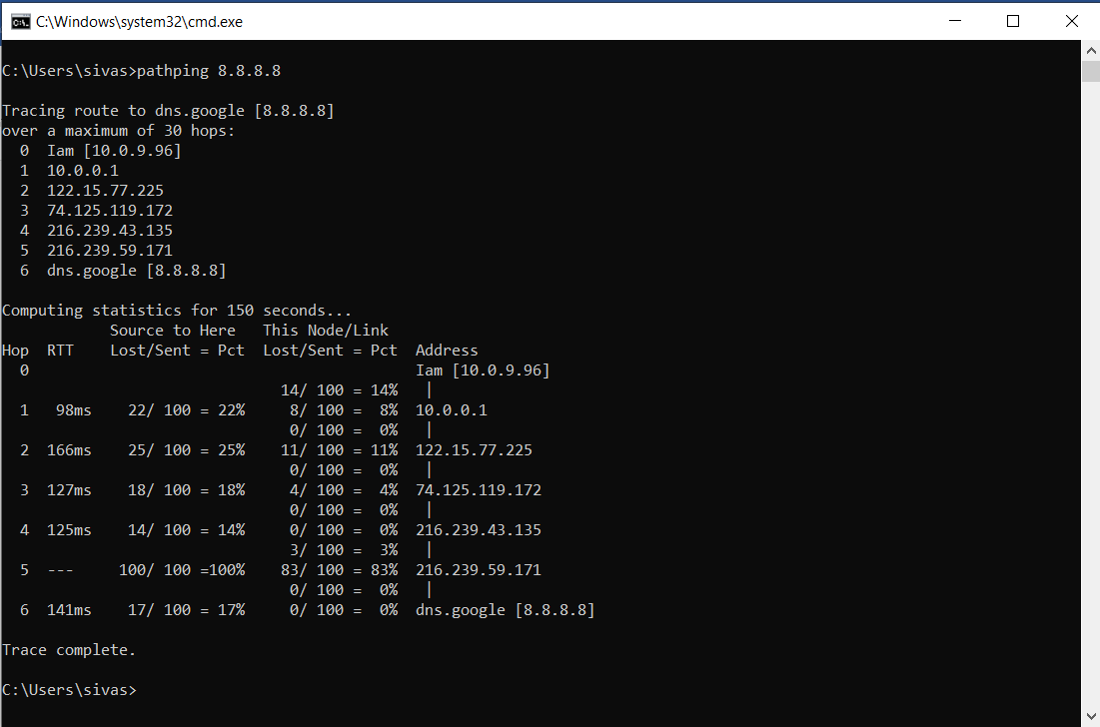

## Tracert

**Syntax: tracert [ip address]**

**Function:** cmd to check the hops and no of router between source and destination.

**More details:** [Refer Microsoft Learn](https://learn.microsoft.com/en-us/windows-server/administration/windows-commands/tracert)

**Example:**

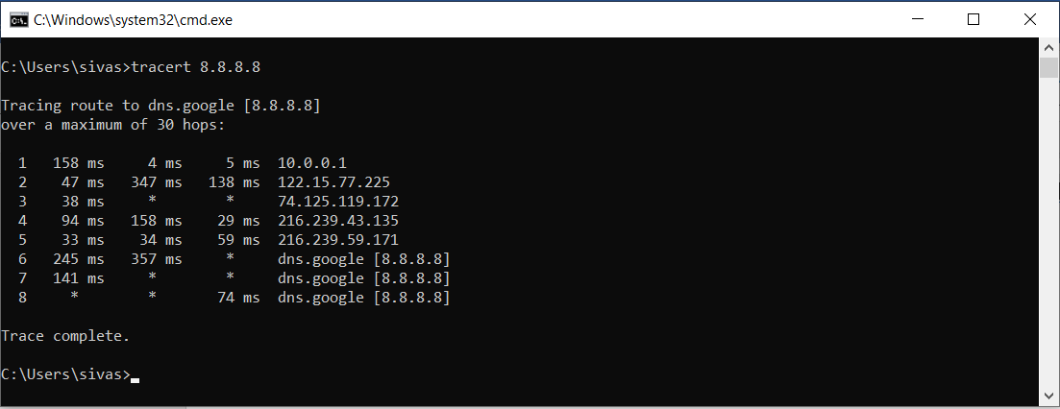

## Nslookup

**Syntax: nslookup**

**Syntax: nslookup [domain name]**

**Function:** cmd to resolve the dns name to ip.

**More details:** [Refer Microsoft Learn](https://learn.microsoft.com/en-us/windows-server/administration/windows-commands/nslookup)

**Example:**

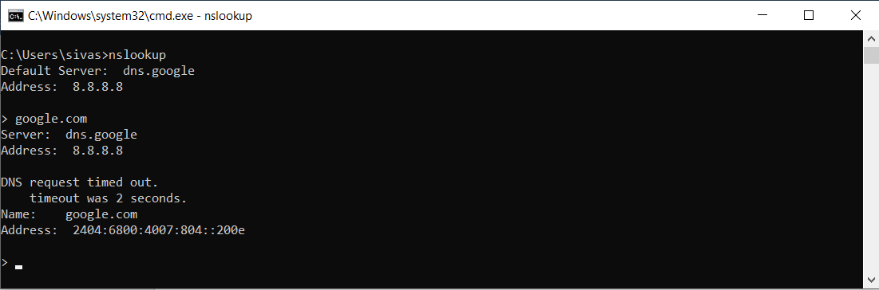

## Wifi Qrcode generator

**Syntax: new-qrcodewifiaccess -SSID "111" -Password "12345678" -outpath "C:/wifi.png"**

**Function:** cmd to genetrate wifi qrcode in powershell

**Installation cmds:** Install-Module -Name QRCodeGenerator

Import-Module QRCodeGenerator

**More details:** [Refer Generate QR Code with PowerShell in Windows 10](https://winaero.com/generate-qr-code-powershell-windows-10/)

**Example:** 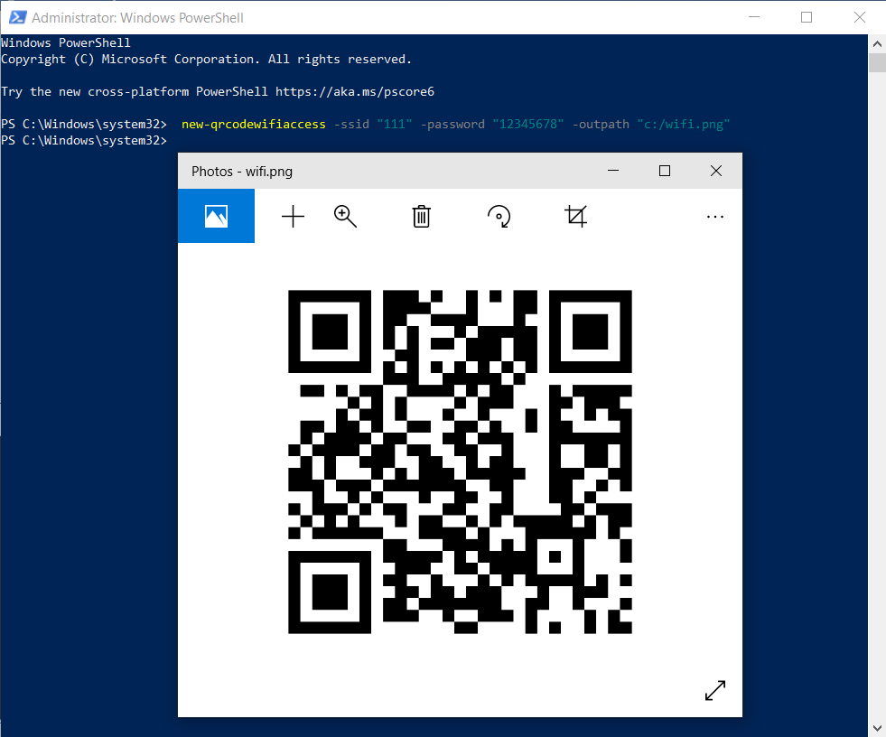

## Attrib Command

**Syntax: attrib “folder_name” +s +h +r**

**Function:** folder is hidden and isn't visible when we select to show all files and folders.

**s** System

**h** Hidden

**r** Read-only

**Syntax: attrib “folder_name” -s -h -r**

**Function:** folder is visible when we select to show all files and folders.

**More details:** [Refer www.c-sharpcorner.com](https://www.c-sharpcorner.com/UploadFile/fd0172/how-to-hide-or-unhide-folders-using-attrib-command/)

**Example:** 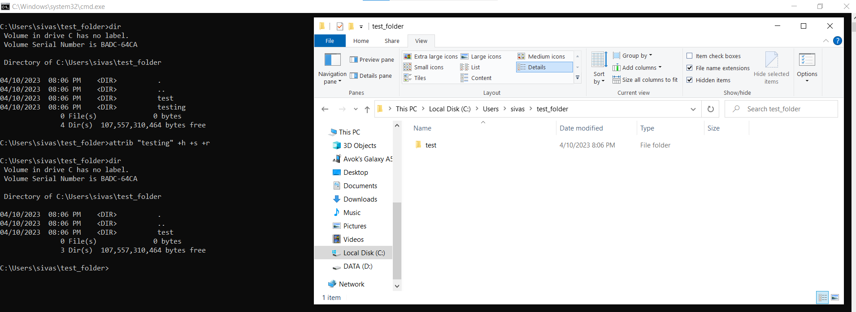

## Title

**Syntax: title [string]**

**Function:** To change the Command Prompt title.

**More details:** [Refer Microsoft Learn](https://learn.microsoft.com/en-us/windows-server/administration/windows-commands/title)

**Example:**

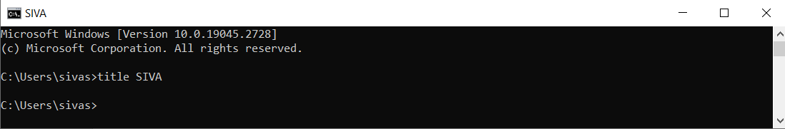

## Prompt

**Syntax: prompt [text]**

**Function:** To change executing path name in command prompt.

**More details:** [Refer Microsoft Learn](https://learn.microsoft.com/en-us/windows-server/administration/windows-commands/prompt)

**Example:** 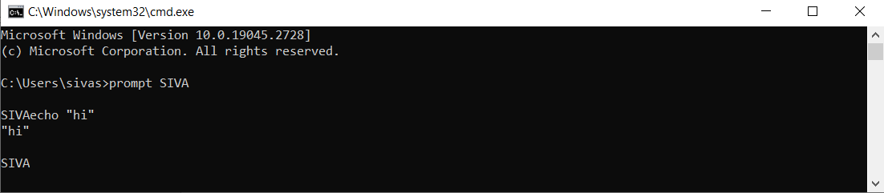

## Netsh

**Syntax: netsh wlan show profile**

**Function:** To show a list of network names that we already connect to.

**Syntax: netsh wlan show profile name= “Wi-Fi name” key=clear**

**Function:** To show the password of the given wi-fi name

**More details:** [Refer Microsoft Learn](https://www.geeksforgeeks.org/how-to-find-the-wi-fi-password-using-cmd-in-windows/)

**Example:** 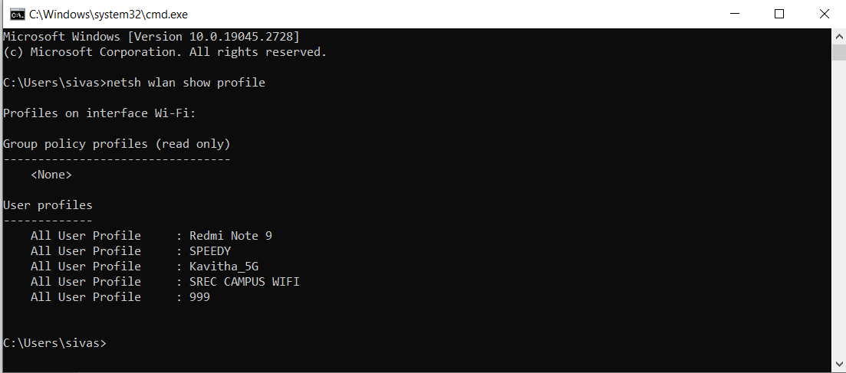

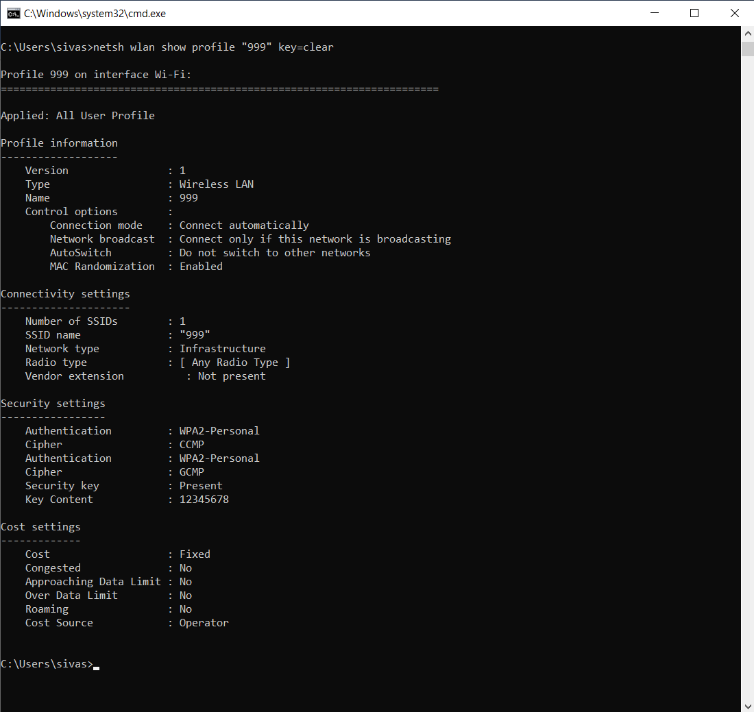

## Manage-bde

**Syntax: Manage-bde -unlock** [drive letter]**: -password**

**Function:** run command prompt in Admin mode to unlock the bitlocker drive.

**More details:** [Refer Microsoft Learn](https://learn.microsoft.com/en-us/windows-server/administration/windows-commands/manage-bde)

**Example:**

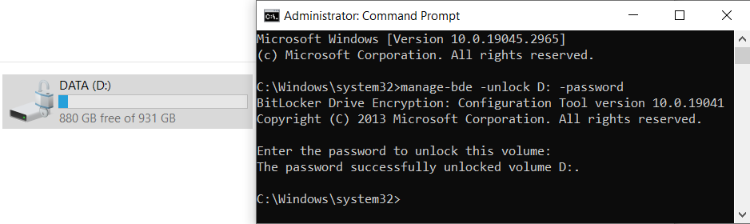

**Here enter the password of Bitlocker dirve.**

**Syntax: Manage-bde -lock** [drive letter]**:**

**Function:** run command prompt in Admin mode to lock the bitlocker drive. If any application or file is opened in that drive location it will not lock.

**More details:** [Refer Microsoft Learn](https://learn.microsoft.com/en-us/windows-server/administration/windows-commands/manage-bde)

**Example:**

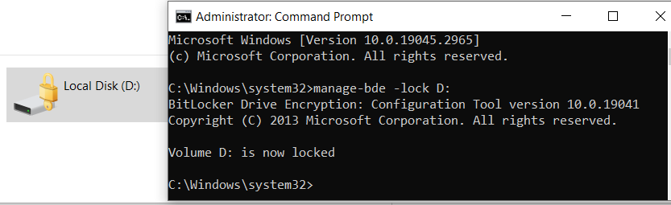

**Syntax: Manage-bde -lock** [drive letter]**: -forcedismount**

**Function:** run command prompt in Admin mode to lock the bitlocker drive. If any application or file is opened in that drive location then also it will lock the drive.

**More details:** [Refer Microsoft Learn](https://learn.microsoft.com/en-us/windows-server/administration/windows-commands/manage-bde)

**Example:**

